
 |  |  | 
 |  |  | 

User Manual – Integration Module

“Framework contract for the provision of forest data and services in support to the European Forest Data Centre”
Reference: 2007/ S 194-235358 of 09/10/2007

Contents

1 Introduction 3
2 Welcome page 4
3 Submit Plot locations 5
4 Submit Strata definition 7
5 Submit forest data 9

Introduction

This document describes the use of the integration module of the E-forest web site.

The data integration module allow a given user to submit two type of data :
- Plot locations, which is valid for all the JRC Request and is using a fixed file format
- Data in response to a JRC Request, with a list of variables that can change depending on the request.

In order to connect on the web site, you must go to the following address: http://efdac.ifn.fr/eforest and click on the login link on the upper right corner of the page.

The user login should have been send by mail.

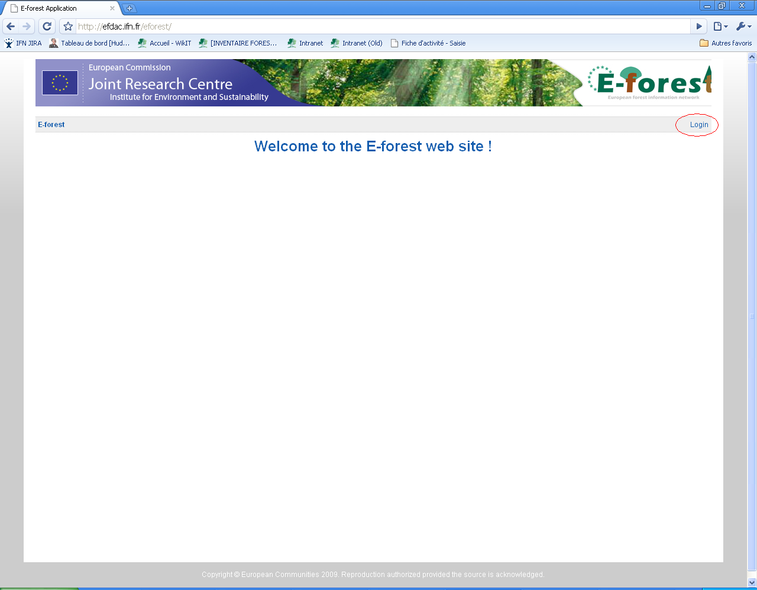

Welcome page

The welcome page of the web site allows you to access the different modules.

Your user should have access to the Data Integration Module. Click on the link.

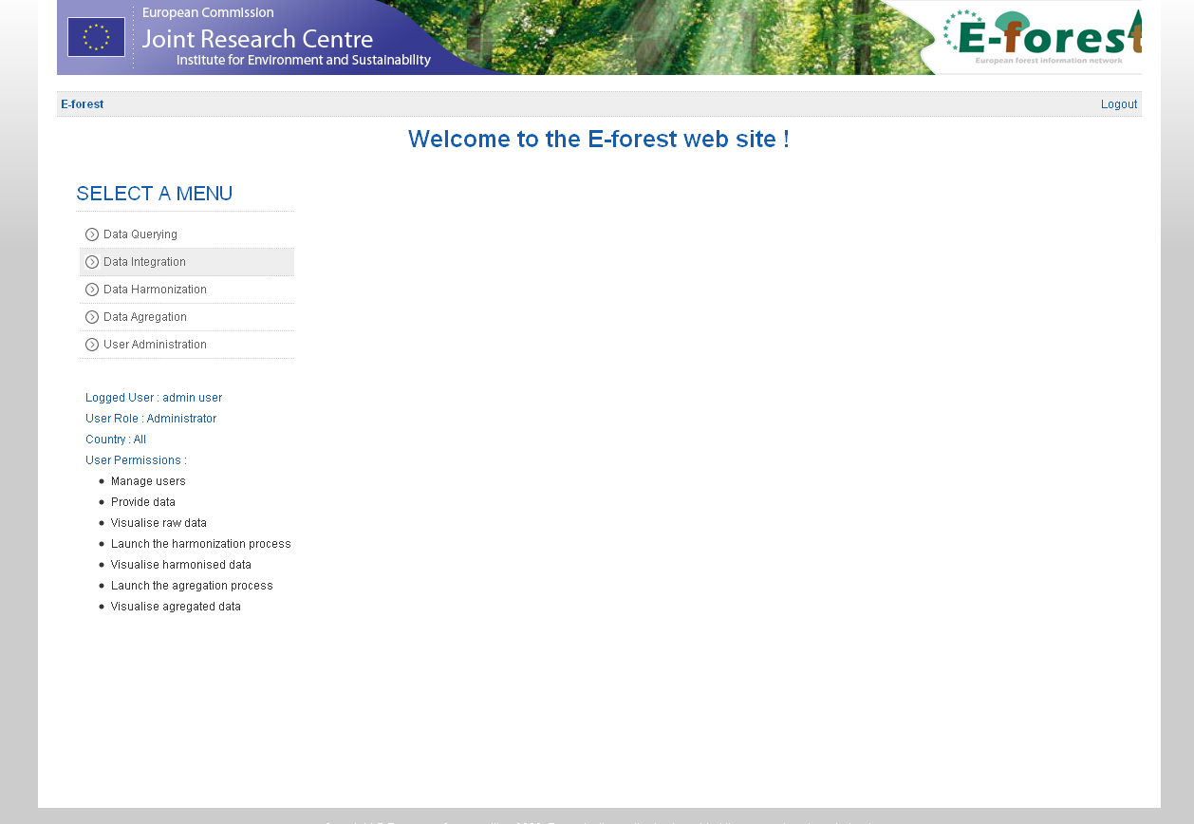

Submit Plot locations

If it is not already done, the first thing to do is to submit in the system the list of plot locations that will be used for all the JRC request.

To do this, click on the “Submit Plot Locations” link.

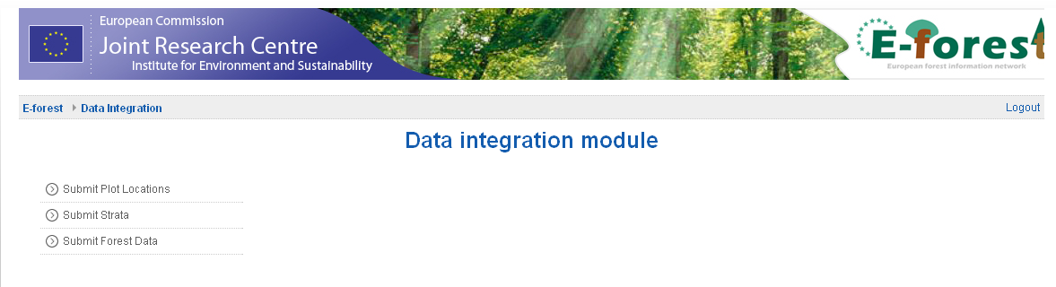

Then click on the “Create new plot location submission” link.
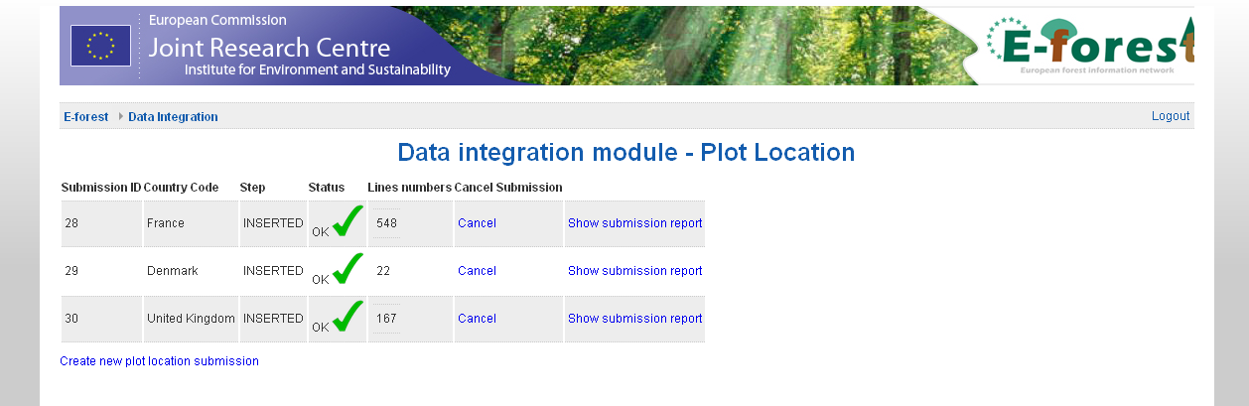

Validate the country

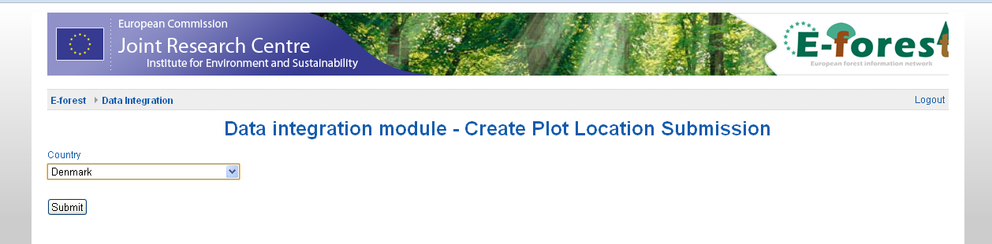

And finally, upload the plot location file.

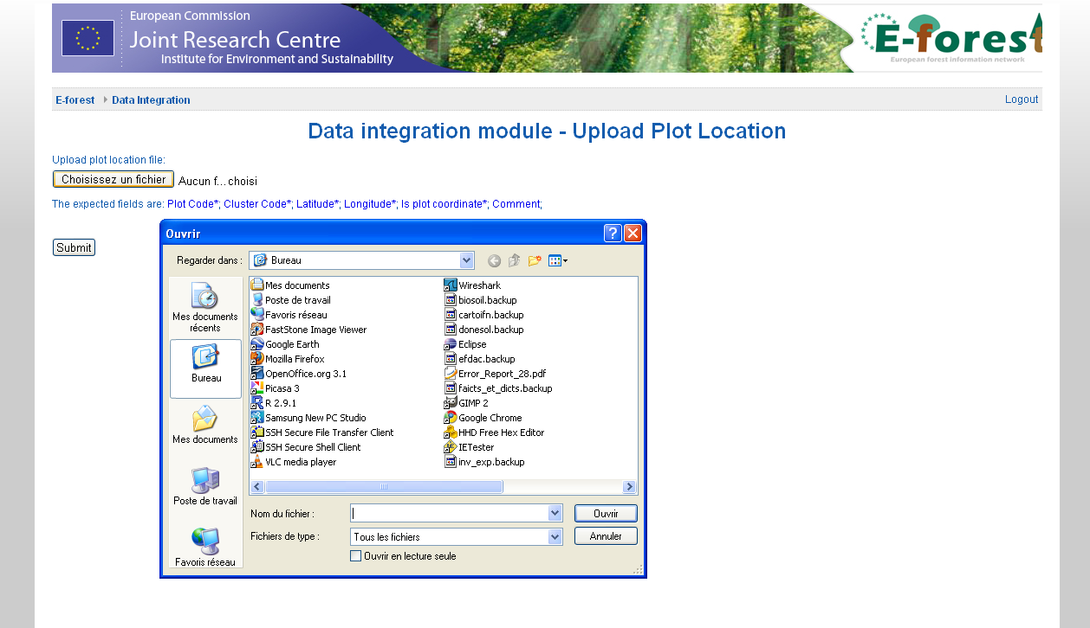

Submit Strata definition

To do this, click on the “Submit Plot Locations” link.

Then click on the “Create new strata submission” link.
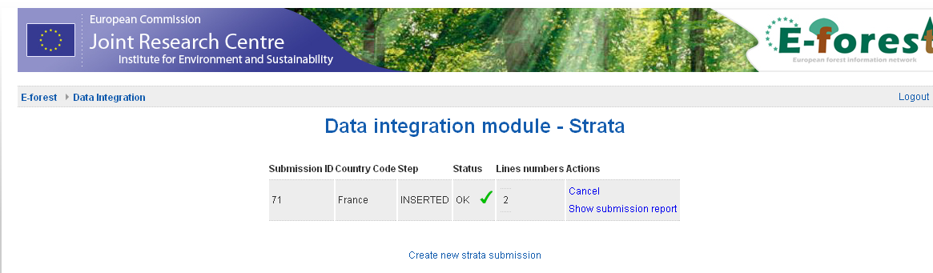

Validate the country

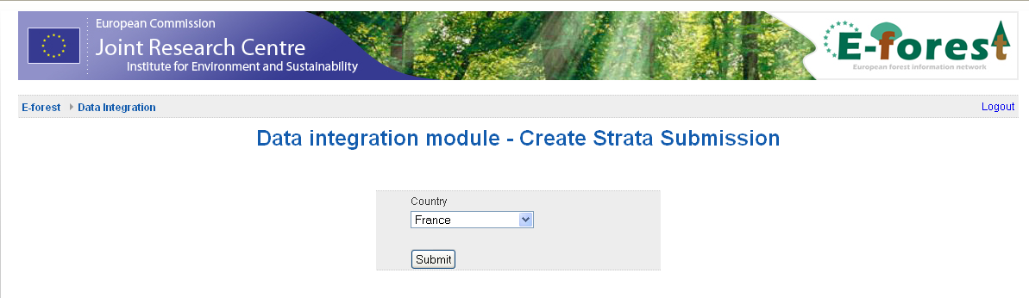

And finally, upload the strata definition file.

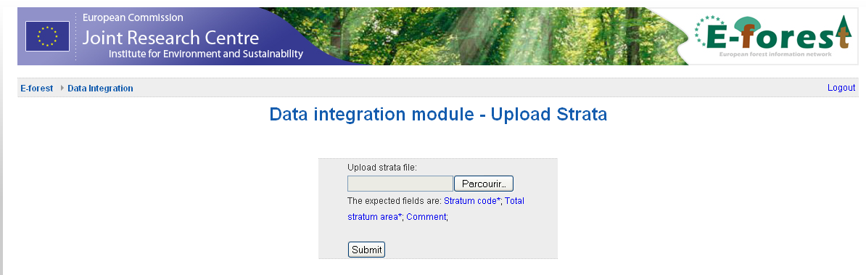

Submit forest data

Click on the “Submit Forest data link”

Click on the “Create data submission” link.

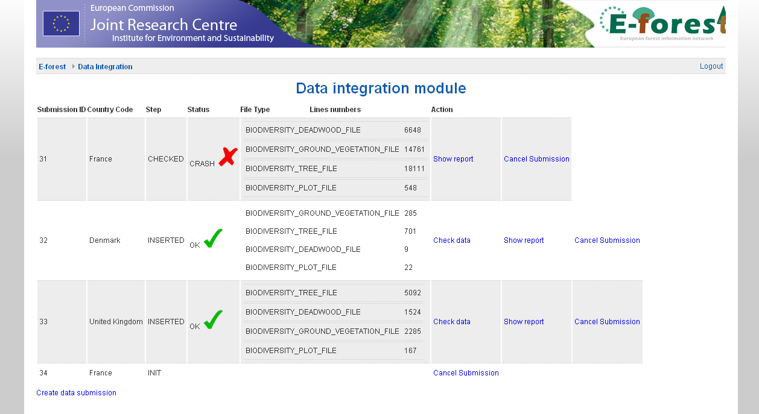

Select a JRC Request and validate the selection of the country.
Eventually, add a comment for the submission.

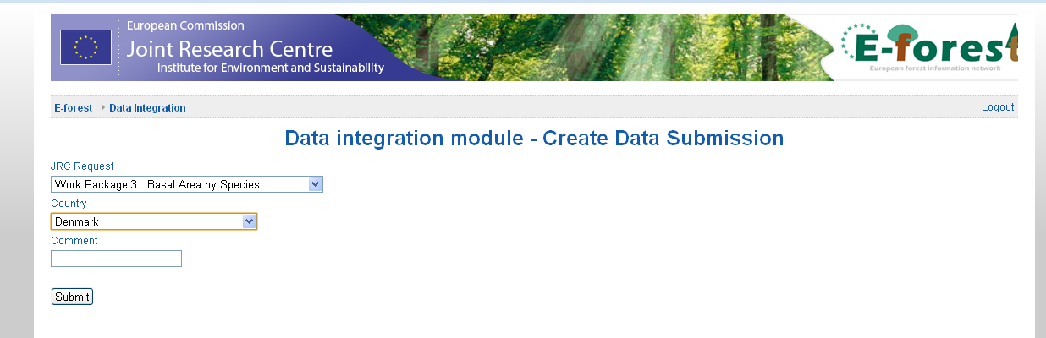

Finally, submit the CSV files that correspond to the selected JRC Request and submit the data.

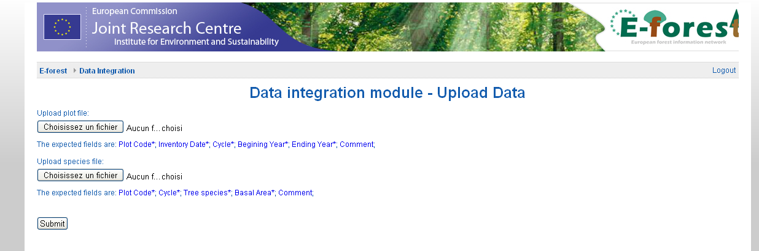

A report on the submission should be available.

